# **Case Study Data Science in Tourism**

## **What is Data Science in tourism?**

The best way to understand data science in tourism is to understand **the concept of data science. I**t refers to various **processes and techniques developed to streamline raw data and use it for effective purpose**. Its primary purpose is to help you **make sense of data and use it to make informed conclusions and decisions.**

Over the years, these processes and techniques have been successfully **automated thanks to sophisticated algorithms.** The travel sector can now efficiently utilize different types.

Here we can analyze data to see exactly what happened, called **descriptive analytics.** We can understand why something occurred thanks to **diagnostic analytics**. Alternatively, we can identify what will happen and what to do next, thanks to **predictive and prescriptive analytics.**

## **Main 4 steps User will go for (ML problem Framing)**

1. Dreaming
2. Research & Booking
3. Experiencing
4. Sharing

## **Use cases of AI/ML in Tourism Industry:**

1. **Route Optimization**

Concept: A customer is always in search of cost-saving and within less time travel solutions. Customers always have in their mind that the **traveling time should be minimum** and the time at the desired location should be maximum. Route Optimization can help to fulfill customer needs and to lure them to grab companies’ tour packages.  
  
 Data Required: Various locations and factors affecting journey time  
  
 Approach: Graph based route algorithms

Effects Experience

1. **Alerting and Monitoring Systems**Concept: find out defects in systems and overcome them. In the touring business many factors such as climate, vehicle failure, staying issues, health-related issues, etc. This alerting and monitoring system helps passengers as well as tourism companies to overcome the problems in the Travel Industry. **Qantas airline** significantly reduced the number and length of delays.  
     
    Data Required: Various factors affecting journey  
     
    Approach: IoT & AI based applications

Effects Experience

1. **Sentiment Analysis** Concept: We can use people’s social media past and existing trends to offer them different tour packages as well as to serve them better.  
   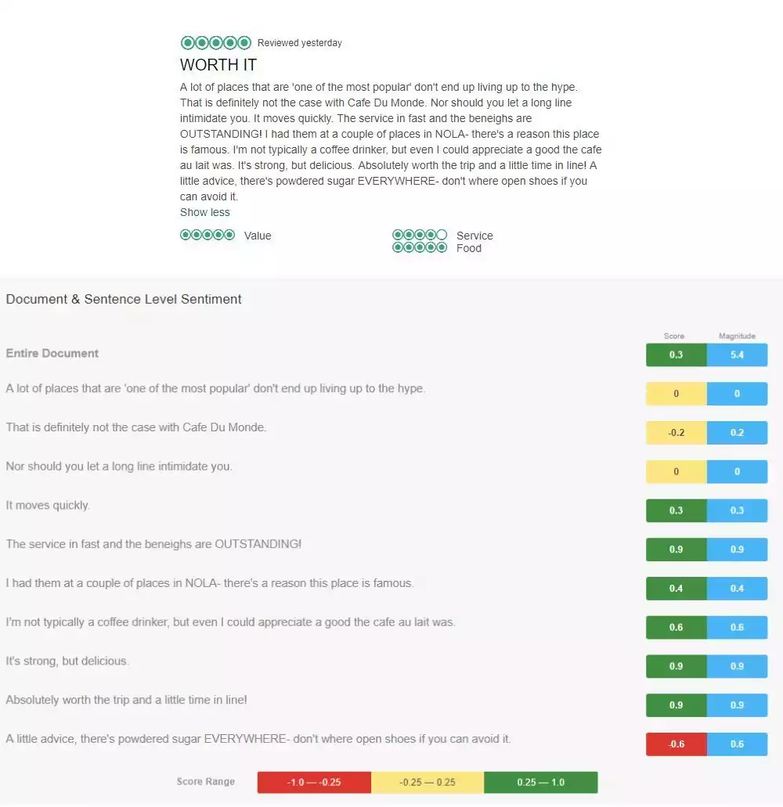

Sentiment analysis of a Cafe Du Monde  
Data Required: Location reviews online  
Approach: data web scraping among social media & website platforms  
Effect will on 4 steps

1. **Predictive Analysis**Concept: use past experience to predict which places will draw more customers & which customers will revisit places, agency etc. Customer segmentations, price prediction and other will be examples of these. **Fareboom, Booking.com**

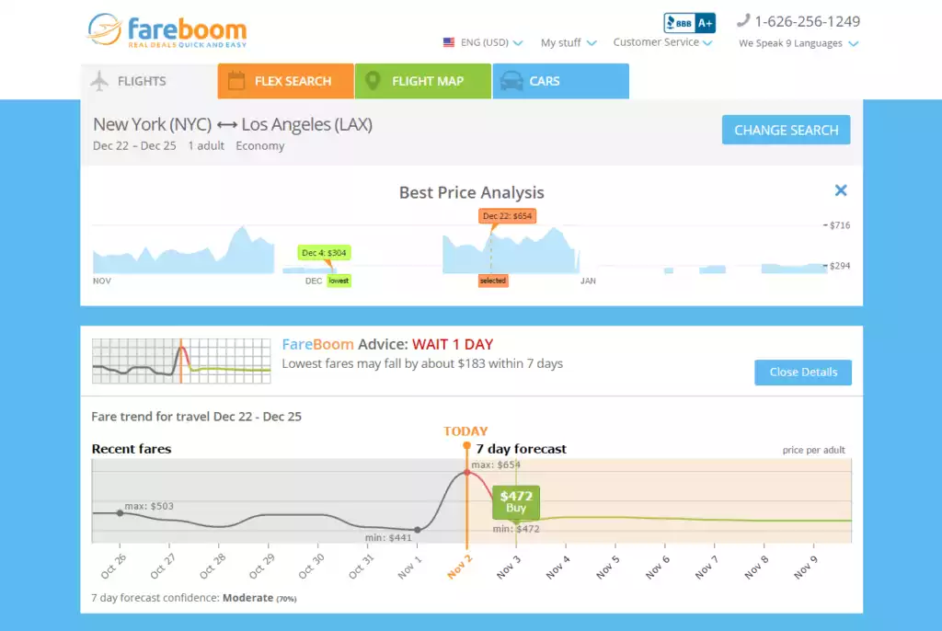

Fareboom price prediction  
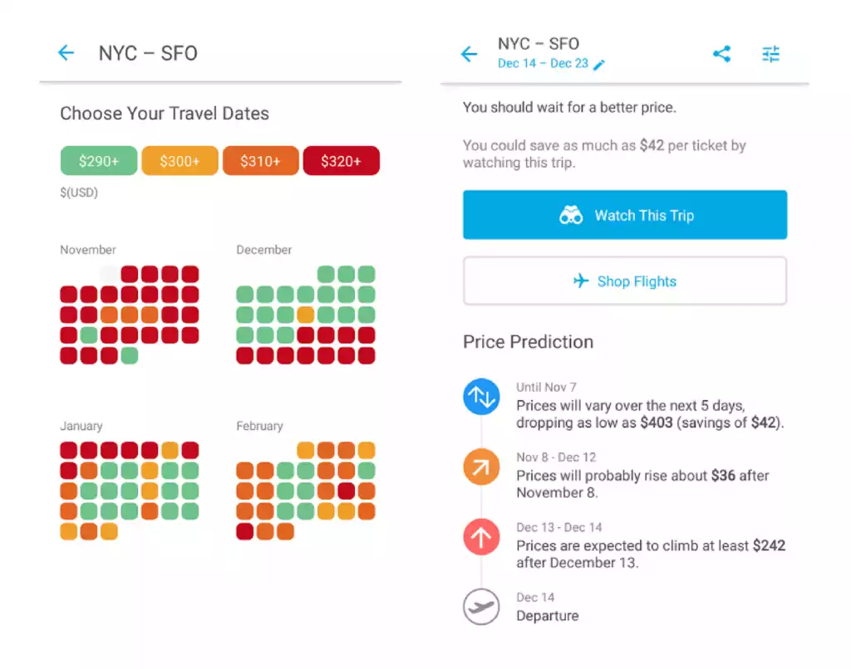

Hopper fare forecast app

Data Required: Booking Data, User reviews  
  
 Approach: general MLOps approach  
Impact to All steps

1. **Personalization / Recommendation System** Concept: Show more related places and packages to afford like with family, couple etc. on specific websites or applications. **Expedia-hotels, Booking.com-destination, Fareboom.com travel agency suggesting alternative dates for a trip**.  
    Data Required: Booking Data  
     
    Approach: Neural Networks

Greatly impact on Dreaming

1. **Intelligent Travel Assistants with Customer Support** Concept: AI algorithms, conditioned to carry out a certain job on a user’s demand, are often called **“Chabot” or “bots”**. Instant messaging applications are extensively used by several prominent companies. This is an excellent strategy to get in touch with customers and develop improved customer relationships with analysis using data science in the travel industry. **Hyatt**  
   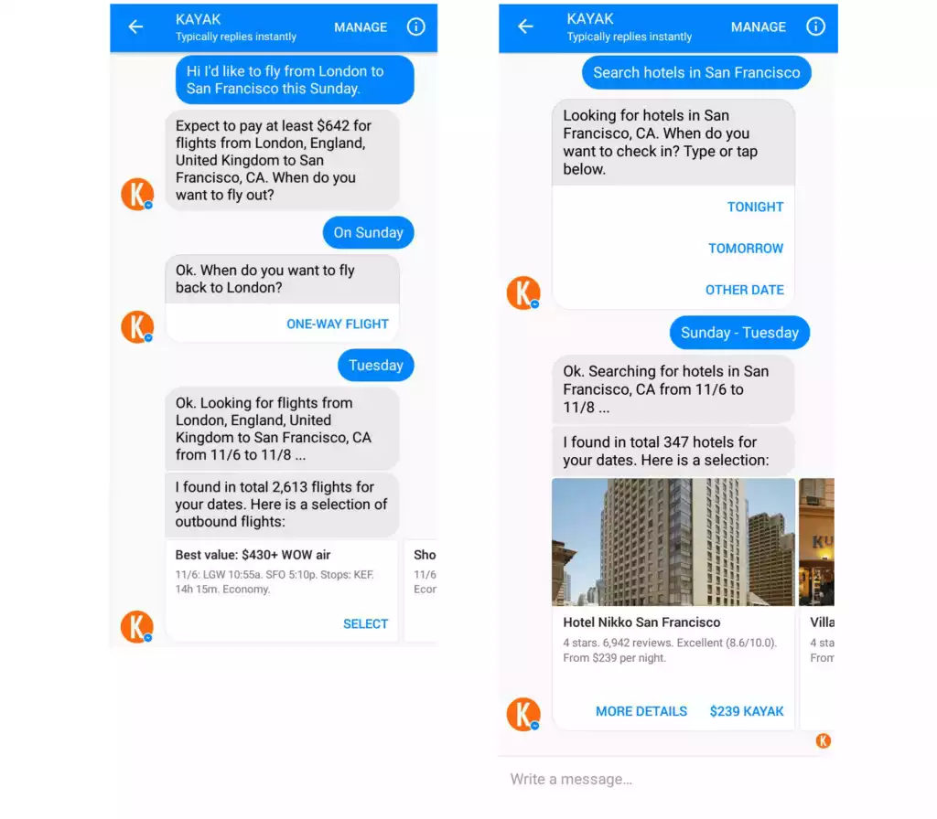

Kayak travel assistant

* + Customer support will allow us to find customer lost assets with help of advanced bot.

Data Required: Booking Data  
  
 Approach: Rasa and pytorch, dialogue flow platforms

Impact on Research & Booking

1. **Travel Fraud Detection**

Concept: Airlines in addition to travel industries confront e-commerce fraud probably the most. They shed billions of bucks each year being forced to **refund money** that is stolen from customers. Transaction fraud is probably the most **widely used kind of scam**.

This specific sector involves using a stolen credit card for booking accommodation or flights. User behavior assessment, user profiling, machine learning solutions, and data science in the travel industry can assist in avoiding and **identifying fraudulent transactions** from transpiring. AI remedies for fraud detection are suitable for web-based platforms and also smartphone booking apps likewise look for personalized models to forecast and identify fraud that authorized them to minimize chargebacks to fifty percent.

Data Required: Booking Data

Approach: proper data modeling and MLOps

Impact will be on owner side revenue optimization

1. **Tailored offers for MVCs** (most valuable customers)

Concept: Tailored offers for new and unregistered users employing and most valuable users that the travel industry plans to focus on first to avoid churn. We can say **customer churn prediction** in the main way.

Data Required: Booking Data, User reviews

Approach: data analysis

Impact on Research & Booking

1. **Descriptive Analysis**

Concept: General Data from Past Approach

* Better understand customers
* Improve brand image
* Dynamic pricing management

Use past experience to predict which places will draw more customers & which customers will revisit places, agency etc. **Venice and Salzburg** as perfect examples of smart tourism destination

Data Required: Booking Data, User reviews

Approach: basic MLops

Impact on all 4 steps

1. **Biometric boarding**

Concept: customer verification purpose in fingerprint or Facial Recognition.

Data Required: User data

Approach: Image Recognition

Impact on experience

1. **Corporate travel and multilingual real-time translation**

Concept: There are several companies such as Pilot and Google Pixel buds that offer a real-time translation service, based on Artificial Neural Networks and Deep Learning. This is a boon for corporate business travelers. These apps operate through an earpiece and offer translation into multiple languages.

Approach: NLP & clustering

Impact on Research and booking, Experience

1. **Employee performance management using AI/ Human resource Management**

Impact on owner side

1. **Automated Equipment in vehicles for customer**s

Impact on Experience

1. **Fuel Consumption Optimization**

Impact on owner side revenue

1. **Turnaround** solution using OpenCV (Aviation)

Impact on owner side revenue

1. **New or Refining Tourism Place search using search patterns vs booking**

Impact in booking

1. **Refine marketing with new AI based keyword advertising**

Impact on owner side revenue

## **Why is Data Science important for the tourism industry?**

The role of data Science in the tourism and hospitality industry is becoming **increasingly important with every passing few years.** Thanks to new IT technologies, companies in the travel sector can now efficiently track, record, store, and process big data, which enables even small companies to **benefit from cutting-edge solutions.**

Advances in cloud technologies and infrastructure that support **big data and data analytics enabled service providers to decrease costs.** It simply means that the travel sector can now use big data in a cost-efficient manner.

Data science unlocks many opportunities for travel companies. First and foremost, it allows people who are not data science experts to **quickly review large-scale volumes of data**. That is important because **most of the touch points consumers have with travel businesses are now online, and each one produces some data.**

Data science can finally equip travel companies with everything they need to understand their target customers and capture more profit – **or, in other words, gain a competitive advantage.**

At the same time, your business also generates internal data. Data Science is essential because you can **truly understand your business processes and how your company interacts with partners and customers.**

Various Techniques going to be used in these:

web scraping, feature engineering, clustering, dimensionality reduction, classification, Regression, hyperparameter tuning, model evaluation, interpretation of models, text representations and word embeddings, Sentiment analysis, Topic modeling, entity matching, knowledge graphs, network analysis, Time series analysis, Agent Based Modeling, GIS Analysis, Visual data analysis

## **Major types of data going to be in Tourism**

### **UGC data (generated by users)**

This abbreviation stands for User Generated Data. This is the cheapest data to obtain and includes textual data obtained from questionnaires and social networks, as well as photo data.

### **Device data (by devices)**

This data is quite expensive to obtain (its cost depends on the territories covered and the period allocated for the study) and includes GPS data, mobile roaming data, Bluetooth data, etc. Generally these data will be of company vehicles.

### **Transaction data (by operations)**

This source includes web search data, web page visit data, online booking data, etc. Typically, advanced web services such as Google Analytics are used to obtain this data.

## **Data Sources:**

* Social Media
* Websites collecting data for travel
* Data sets available in popular platforms like kaggle, airbnb
* Manual Collection in Client environment
* various benchmarking datasets

[AI and Data Science in Aviation Industry: 5 Real-life Use Cases](https://www.youtube.com/watch?v=D8NlYPtPgwA&ab_channel=AltexSoft)

[Impact of Data Science on Tourism Industry | How Data Science is Used in the Travel Industry](https://youtu.be/a1FB3KUWp08)

[Machine Learning and Artificial Intelligence in Travel](https://www.youtube.com/watch?v=xjLNBwZHUtA&ab_channel=HSMAI)

[SMART TOURISM : Big data, artificial intelligence and robotics revolutions](https://youtu.be/d9nP05RTu4Q)